ACTIVE DIRECTORY WITH SPLUNK INTEGRATION LAB SETUP

This project involved setting up an Active Directory lab that includes a Splunk server, Kali Linux & Atomic Red Team. I explored how a domain environment works, creating users in active directory, learnt how to ingest events to a SIEM (SPLUNK), and generate telemetry related to attacks seen in real life to help detect them in the future. I gained practical insights into creating users on active directory, event ingestion into a Security Information and Event Management (SIEM) system, specifically Splunk. By simulating real-world attacks and generating telemetry data, I honed my ability to recognize and respond to security threats effectively. This setup not only provided hands-on experience but also underscored the importance of proactive measures in enhancing cybersecurity posture.

**The Setup**

In this project, VirtualBox was the virtualization software utilized to create the lab which consisted of four (4) virtual machines (VMs). The following virtual machines were provisioned or installed on VirtualBox:

1. Windows server 2022: This will provide our active directory service. This will be configured to send logs to the Splunk server.
2. Ubuntu Server: This will be the host for Splunk.
3. Windows 10 Machine: This will serve as the target machine. This will also be configured to send logs to the Splunk server.
4. Kali Linux: This will serve as the attacker.

The above setup is logically represented with the following diagram:

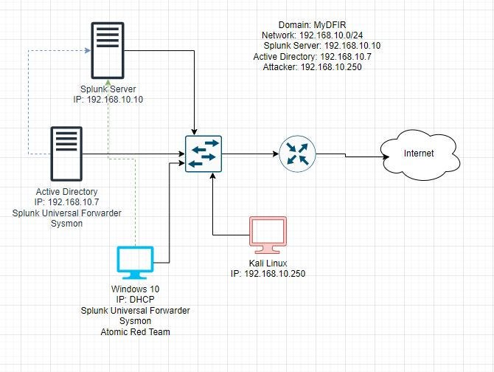

Network Diagram of the setup

**Configuration of the setup**

Following the installation of the Ubuntu server, Windows server 2022, Windows 10, and Kali Linux VMs on VirtualBox, I followed the following steps to configure the VMs:

1. Create a NAT network, and adjust the network settings of the VMs to all be on the created NAT network. This will ensure that the 4 VMs will be on the same network and also have access to the internet through the host machine.

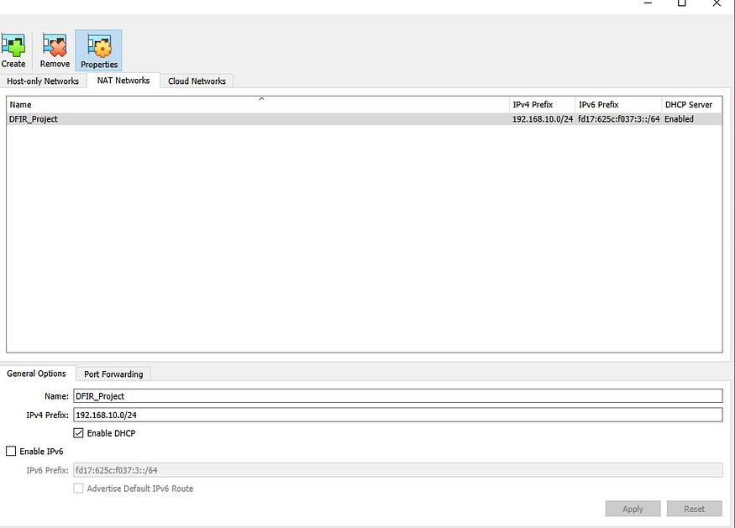

NAT Network for the VMs

2. To ensure uniformity when accessing my Splunk instance, set the ubuntu server to have a static IP address of 192.168.10.10, and DNS server address of 8.8.8.8.

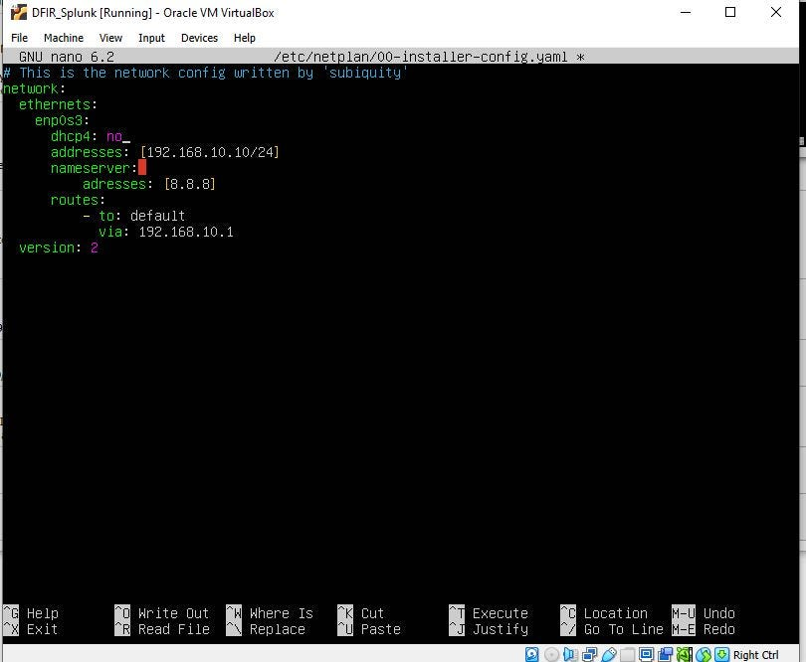

Static IP setting for Splunk server

1. On the Ubuntu VM, visit Splunk.com and sign up to download and install the free edition of Splunk Enterprise. Alternatively, you can do the above on your host machine, and create a shared folder on the Ubuntu machine to access the downloaded installation file.

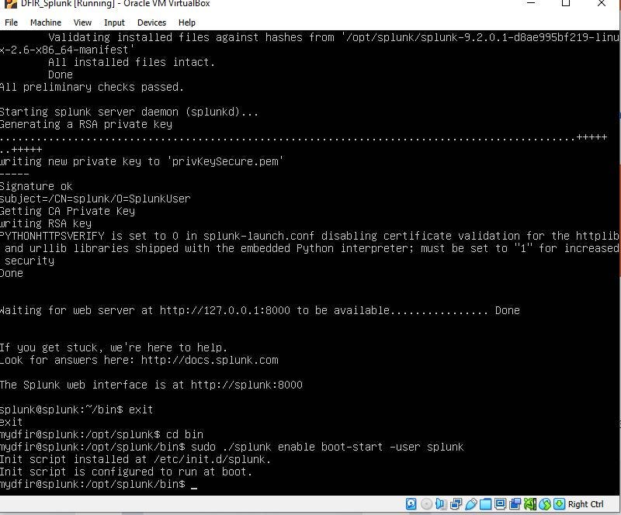

Splunk successfully installed on Ubuntu

4. On the windows 10 machine, change the hostname to target-PC for easy identification on Splunk. Also, to prevent IP conflict, configure a static IP address of 192.168.10.100. Test the setup connectivity by accessing the configured Splunk instance on 192.168.10.10:8000.

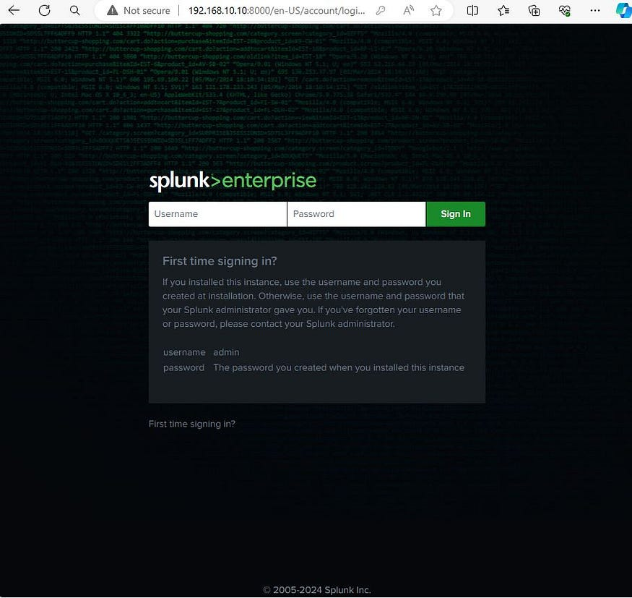

5. From the target-PC, visit- splunk.com, to download and install Splunk universal forwarder. The Splunk universal forwarder ensures specified telemetries can be sent to the Splunk server.

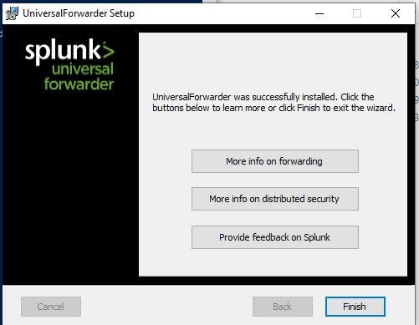

6. From the target-PC machine, visit the Microsoft website (learn.microsoft.com) to download sysmon. Then, search for and download, and then save the sysmon configuration file by olafhartong. Install sysmon, by specifying the downloaded configuration file.

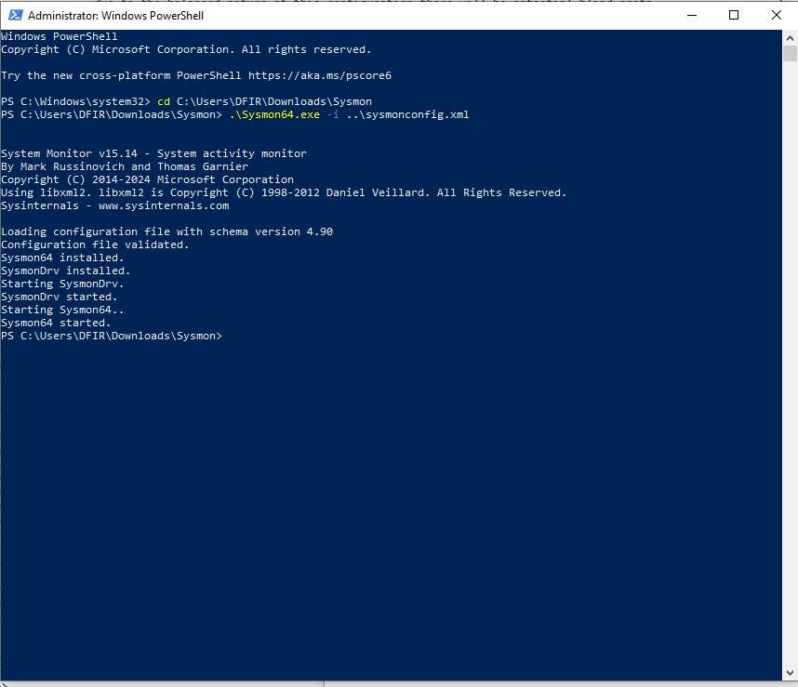

Sysmon Installed

7. Next instruct the Splunk forwarder on the telemetry to collect from the target-PC by creating and configuring an input.conf file in the C:\Program Files\SplunkUniversalForwarder\etc\system\local folder using administrative privilege. The specified events on the input.conf file will be forwarded to Splunk.

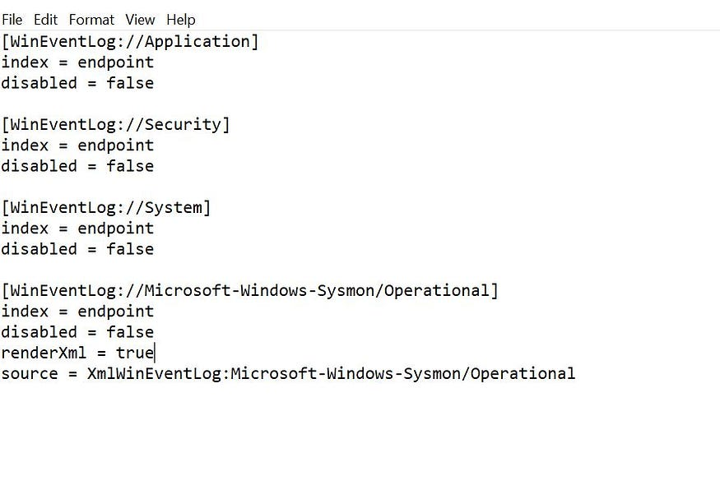

Input.conf file

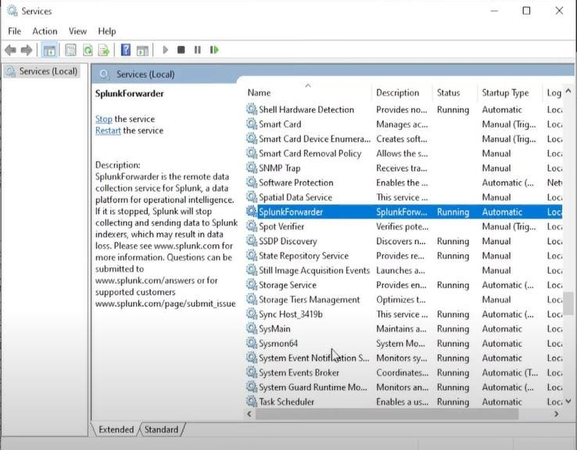

Restart the Splunk Forwarder service on services.msc

8. Log on to the Splunk instance on 192.168.10.10:8000 and configure the Splunk to listen on the default port of 9997 to receive telemetries from the Splunk forwarder

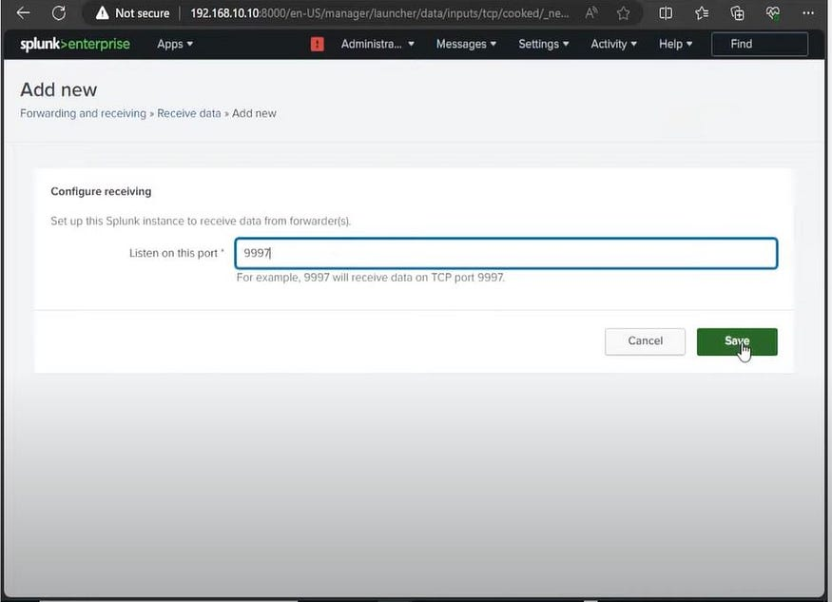

9. On the search and reporting App of Splunk confirm that the target-PC is visible as a host.

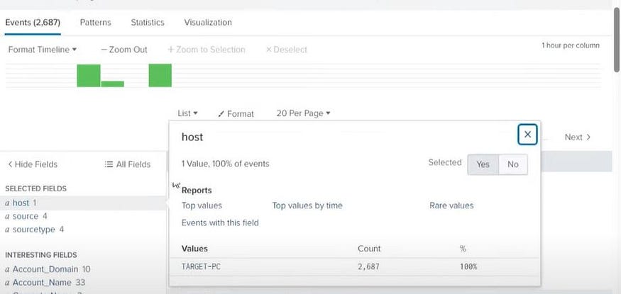

10. Repeat steps 4–9 on the Windows server 2022 (WINSRV).

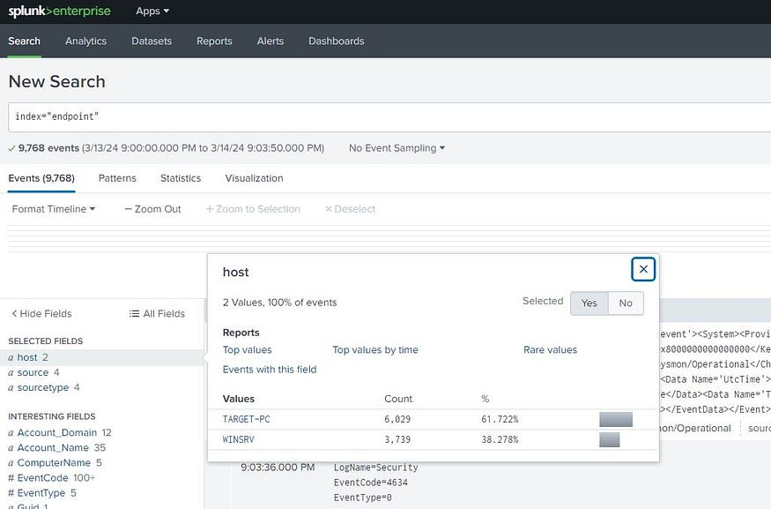

11. Configure a static IP address of 192.168.10.7 for the Windows server (WINSRV)

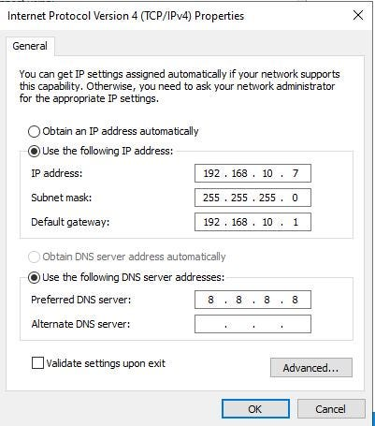

12. Install the Active Directory Domain Service role on the WINSRV and promote it to a domain controller with domain name configured as mydfir.local

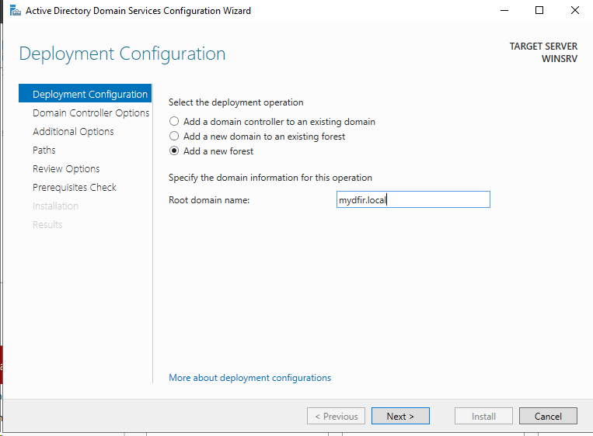

On successful installation of the Active Directory service and promotion to a domain controller, when the system restarts, the log on screen will be as shown below:

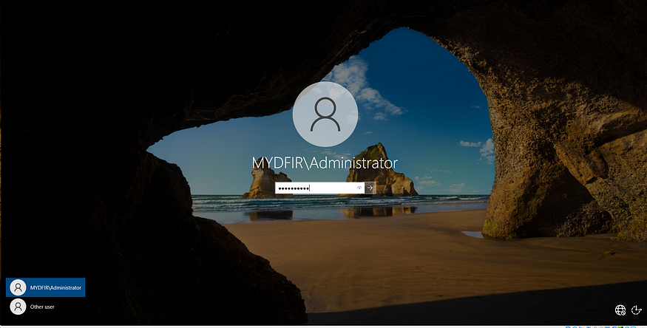

13. Create two organizational units (OU) named IT and HR, and create a user each in each OU.

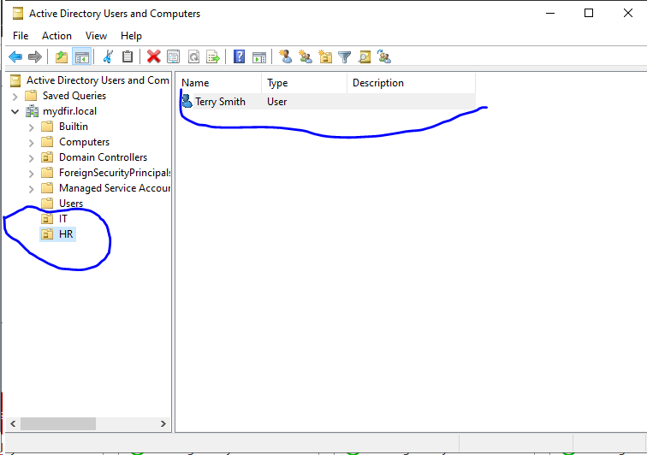

14. Join the Target PC (Windows 10) machine to the domain. Search for PC and click on properties and then click on Advanced system settings.

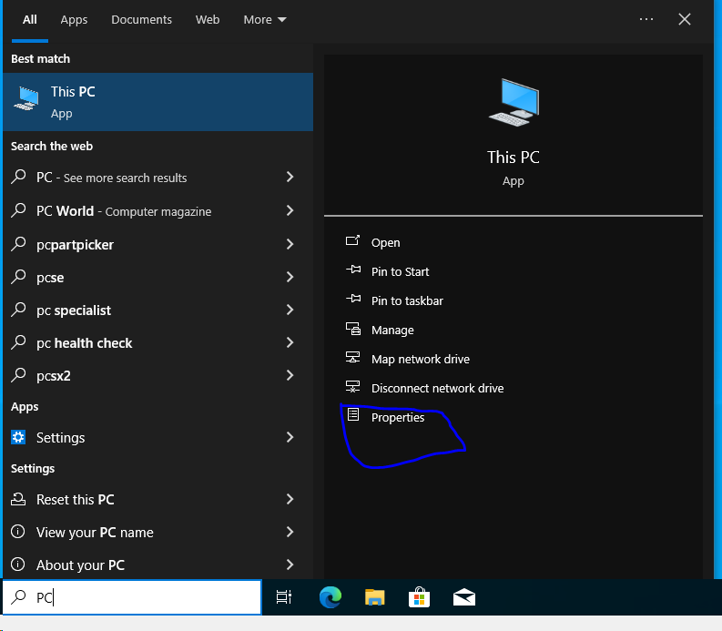

Click on Computer Name, select domain, and type the domain name MYSPACE.LOCAL

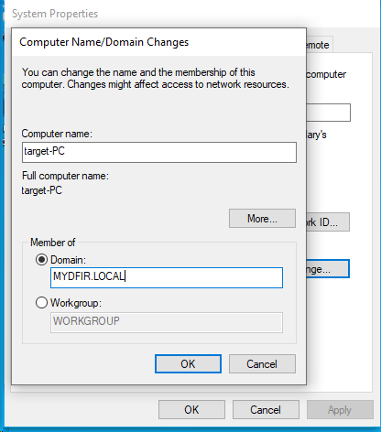

Click OK. An error might pop-up. This is because the windows machine do not know how to resolve MYDFIR.LOCAL

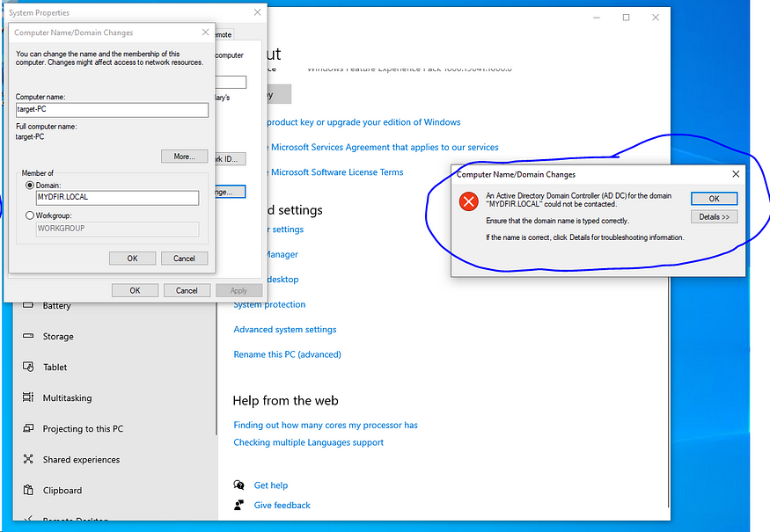

To fix this right click on adapter and select Network and Internet settings, and click on change adapter options. Right click on the adapter and select properties and select Internet Protocol Version 4. Chane DNS server which is pointing to 8.8.8.8 to the domain controller on 192.168.10.7.

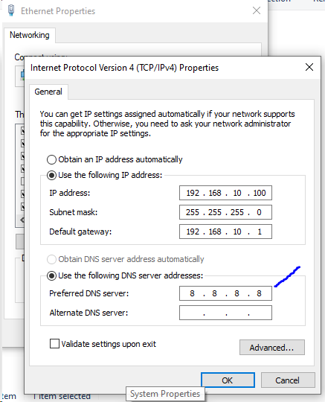

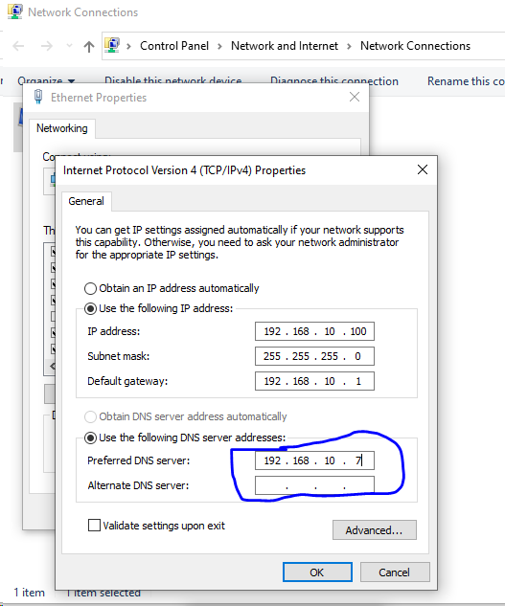

To confirm that this change has been effected, open the command prompt and type ipconfig /all.

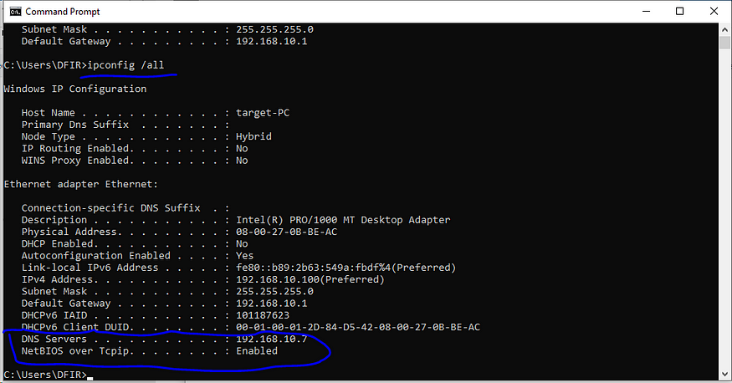

15. Proceed with joining the Target PC (Win 10) to the domain.



You will receive a prompt to enter a name and password. Enter Administrator and the password.

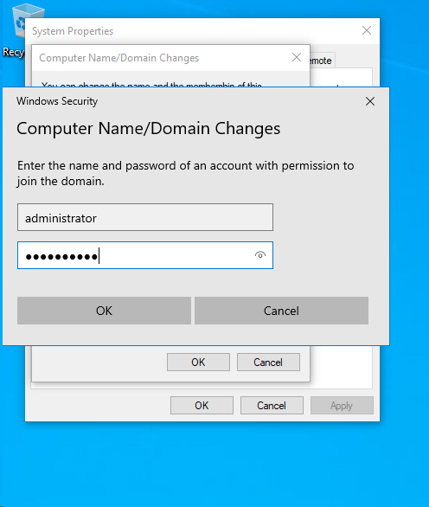

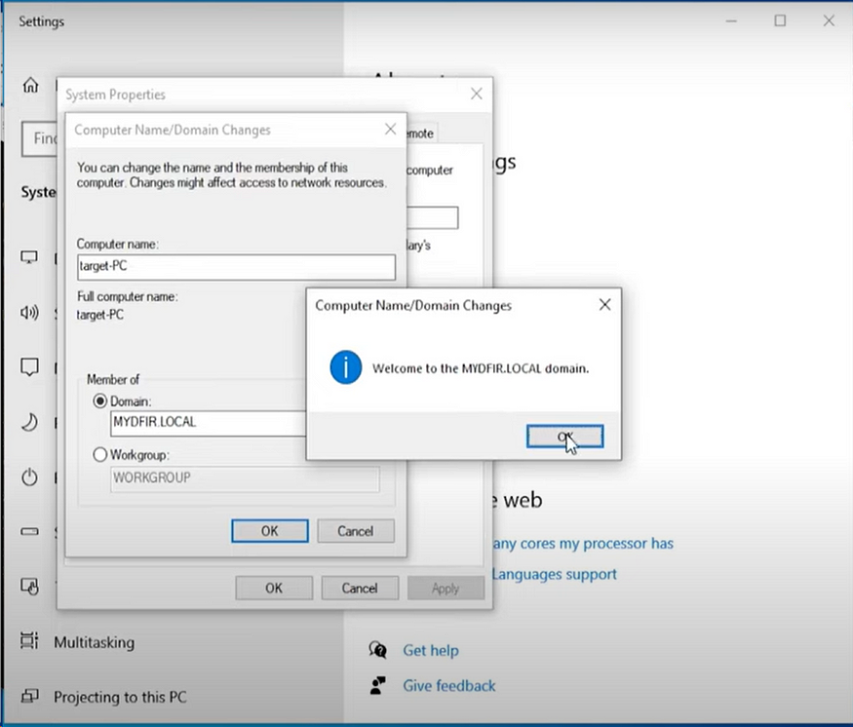

16. Set a static IP address of 192.168.10.250 as depicted on the network diagram for the Kali Linux machine by right clicking the internet connection at the top and select edit connections. Select the first profile and changed the method to manual, and configure as shown below.

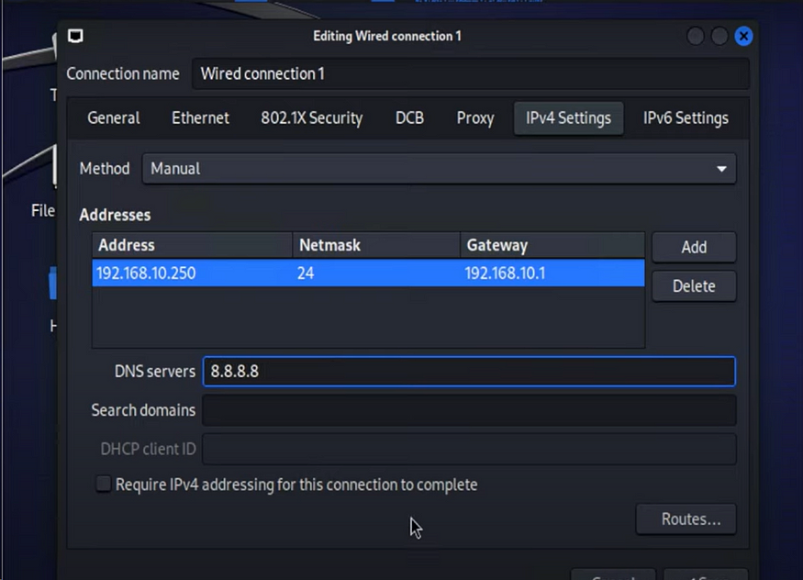

To effect the change, click on the internet icon to disconnect and and then reconnect, and confirm by using the “ip a” command on the terminal.

17. Create a folder named ad-project, that will contain the files employed to attack the target windows 10 machine.

18. Install crowbar by typing the following command: sudo apt-get install -y crowbar. Crowbar will be be used to perform a brute force attack.

19. Change directory to usr/share/wordlists folder to access the rockyou.txt.gz file that comes with Kali Linux.

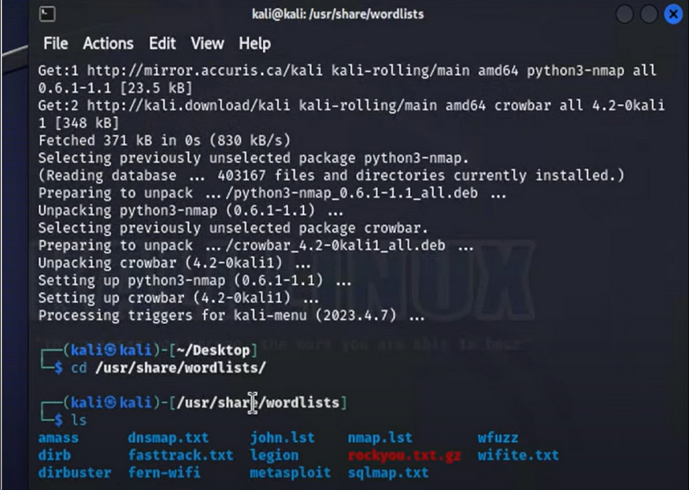

Unzip the rockyou.txt.gz, and copy the text file to the ad-project directory. Switch to the ad-project directory. Output the first 20 lines of the rockyou.txt file to a file passwords.txt using the command shown below:

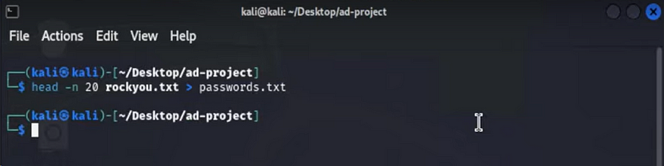

To view the content of the password.txt file, type cat passwords.txt.

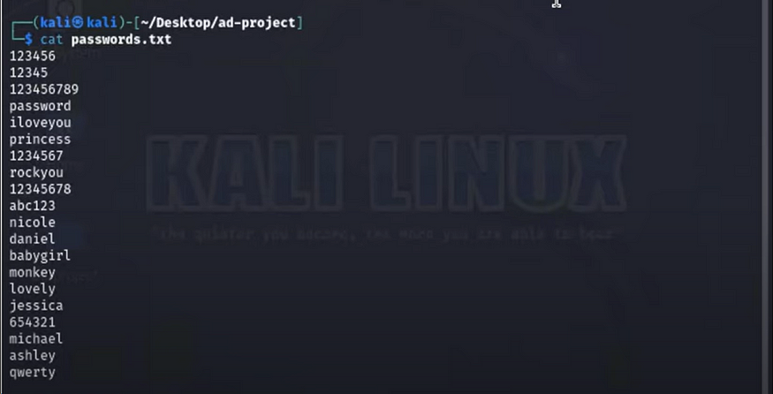

Edit the content of the passwords.txt file and include the correct password of one of the user accounts created on active directory.

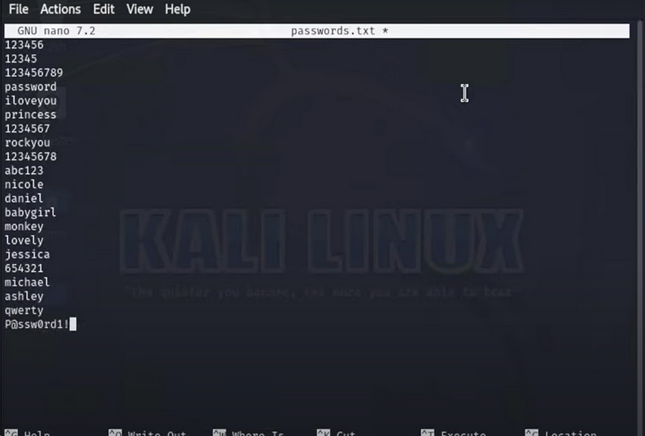

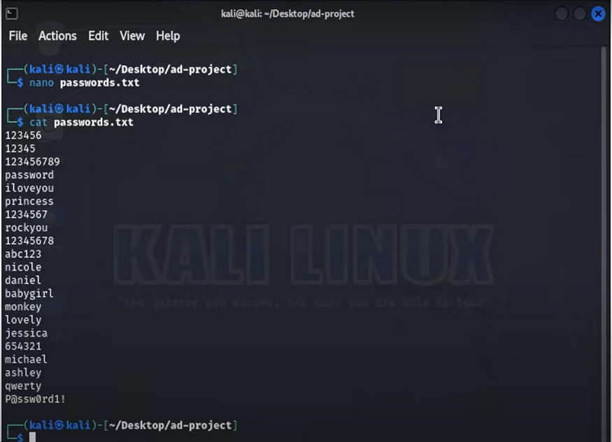

20. On the windows 10 machine, enable remote desktop by going to advanced system settings, and select users.

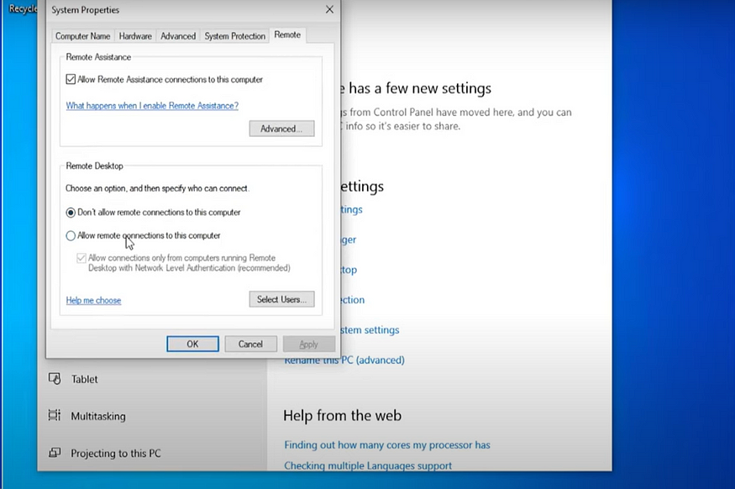

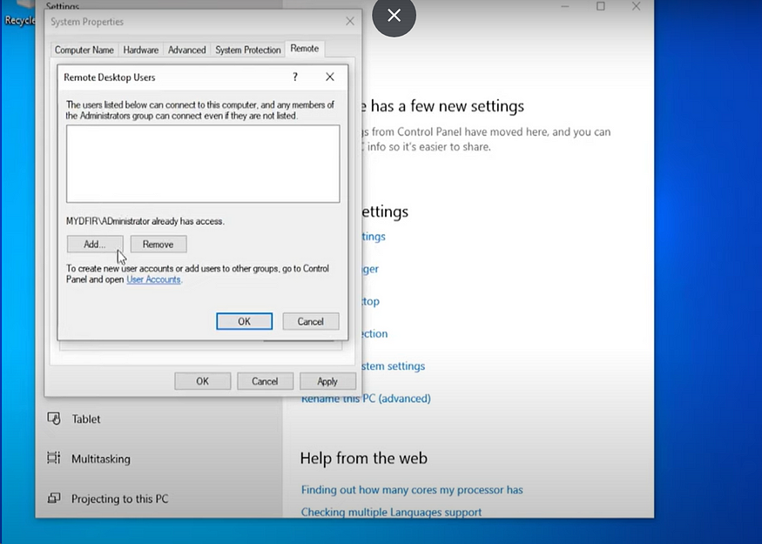

Add the 2 users created in active directory.

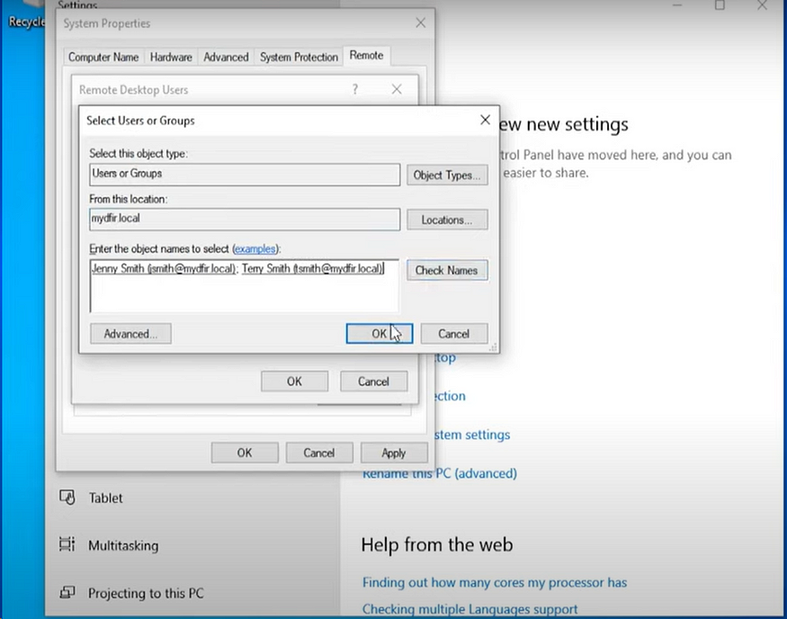

21. From the terminal of the Kali Linux machine, use the crwobar tool and the passwords.txt file to launch a password attack on the windows 10 machine using the following command:

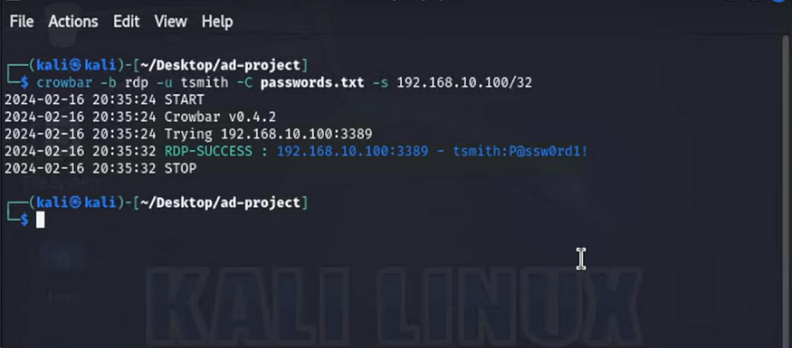

Note that /32 notation was used as the attack in this lab was aimed at the windows 10 machine, and not the entire network. Crowbar will try every password on the passwords.txt file to establish a remote connection. When crowbar is successful, it will show success and the password use.

22. To see the telemetry generated by this attack, log on to Splunk, and select the Search and Reporting app. Enter the specific search command: index=endpoint tsmith.

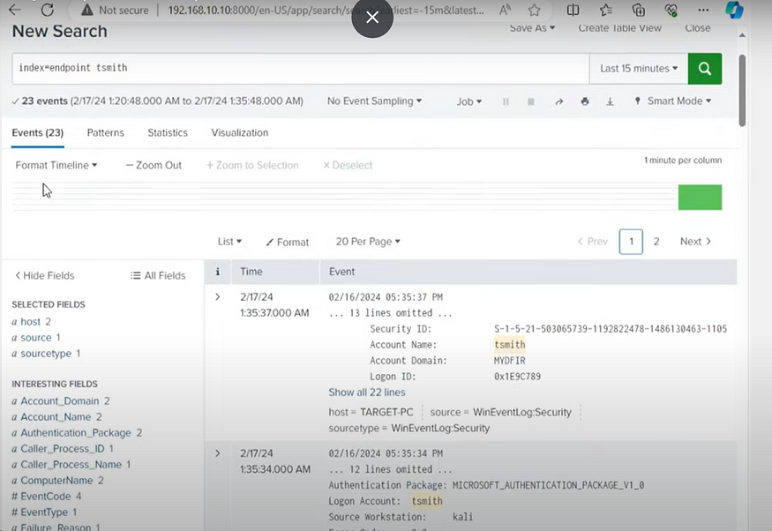

The number of events returned from the search is 23 which is indicative of the number of password attempt specified on the passwords.txt file.

23. Scroll down to the field name “EventCode”, an event count of 20 for event 4625, and a single count of event 4624 are observed.

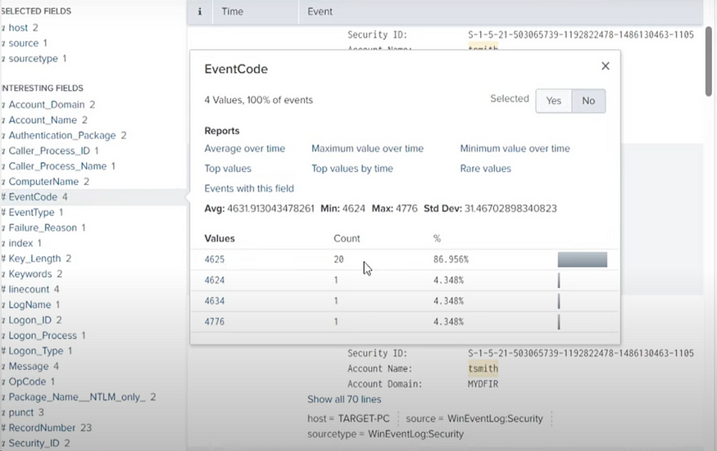

A quick google search of event 4625 and 4624 showed the events relate to failed log on attempt and successful log on respectively.

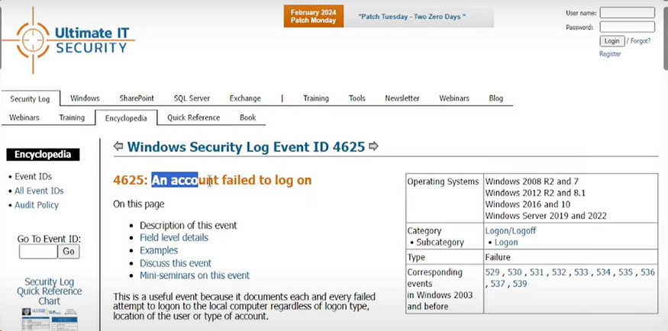

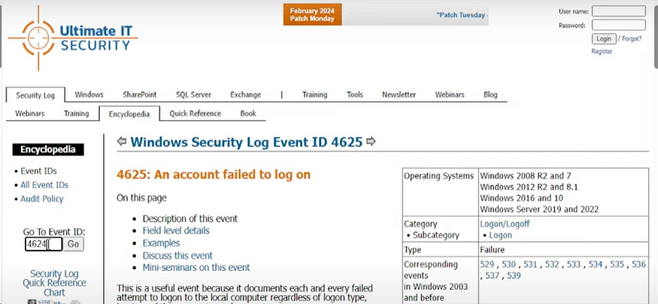

Add “EventCode=4625” to the search on Splunk, it can be observed that all the events occurred at the same time which indicates a “brute force attack”.

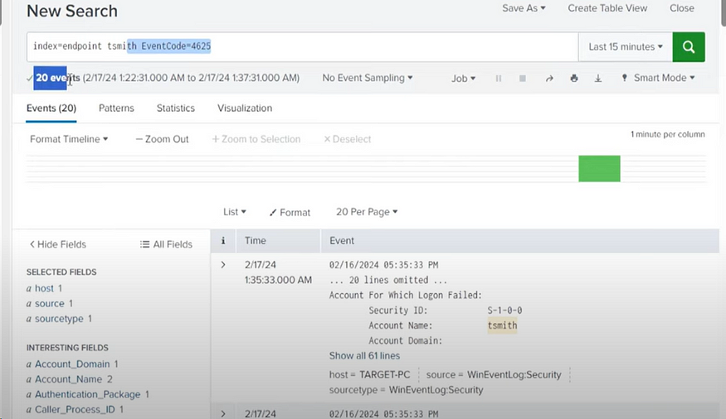

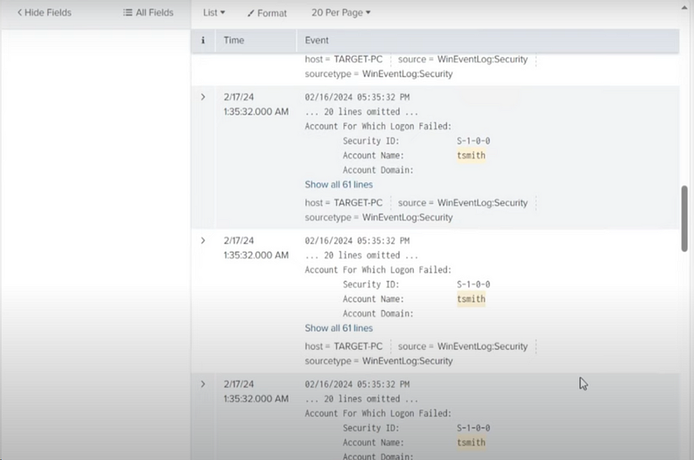

Adding “EventCode=4624” on Splunk search reveals the one successful log on. Drilling down to the 70 lines of this event reveals the attack sources as the Kali Linux machine.

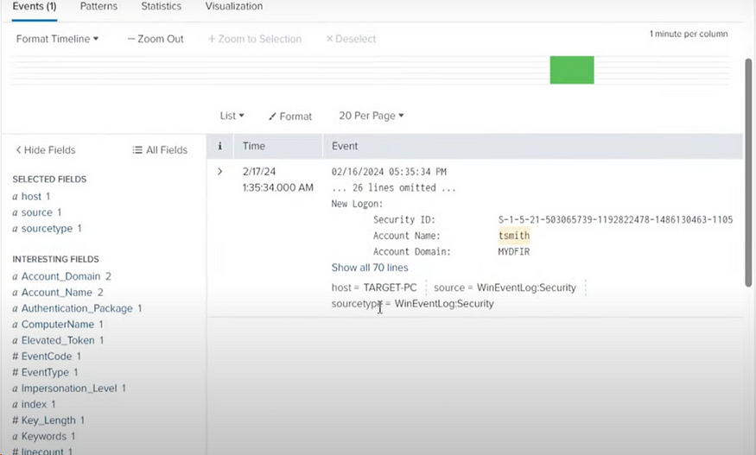

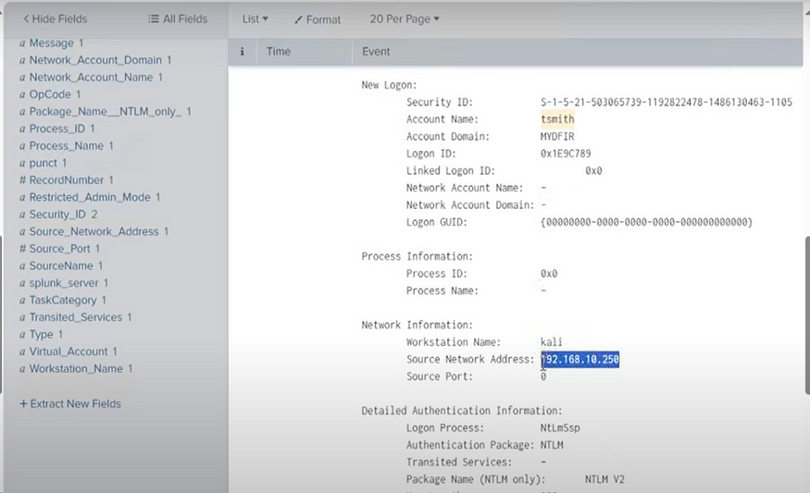

24. Install Atomic Red Team on the target machine (Windows 10) using the following commands from PowerShell below. Exclude the C:/ drive on windows defender to prevent windows defender from deleting the contents of AtomicRedTeam.

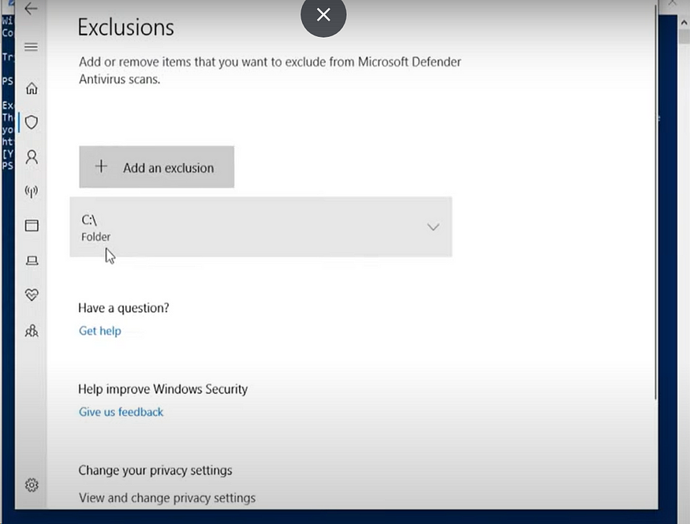

Install AtomicRedTeam using “Set-ExecutionPolicy Bypass CurrentUser” and then followed by “Install-AtomicRedTeam -getAtomics”.

On completion of the download, AtomicRedTeam is accessible on the C: drive.

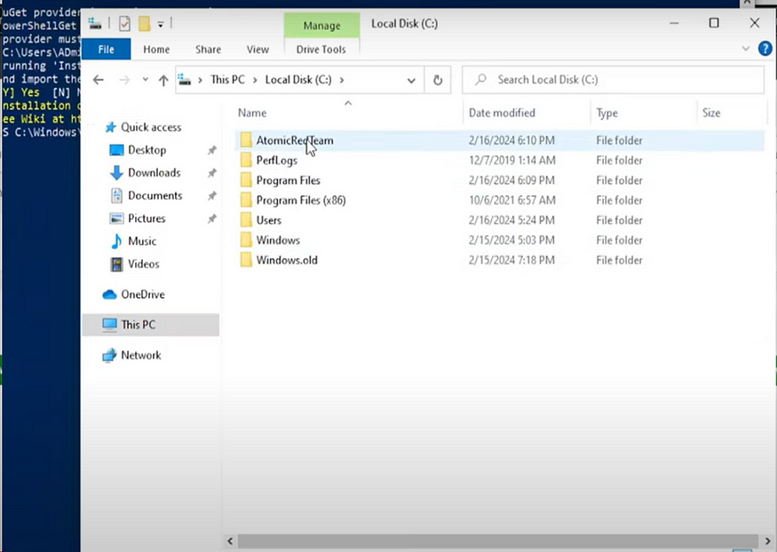

The Atomics file contain techniques that match to the MITRE Attack Framework.

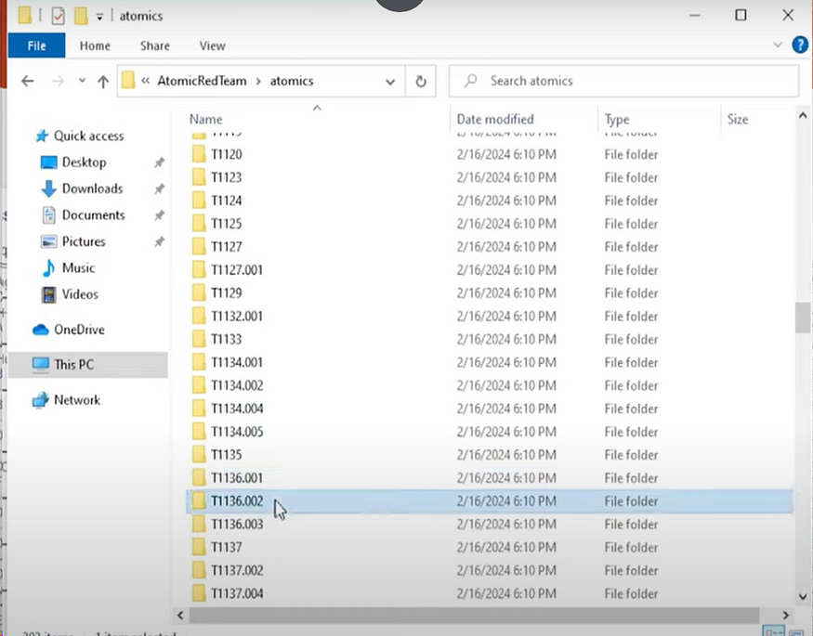

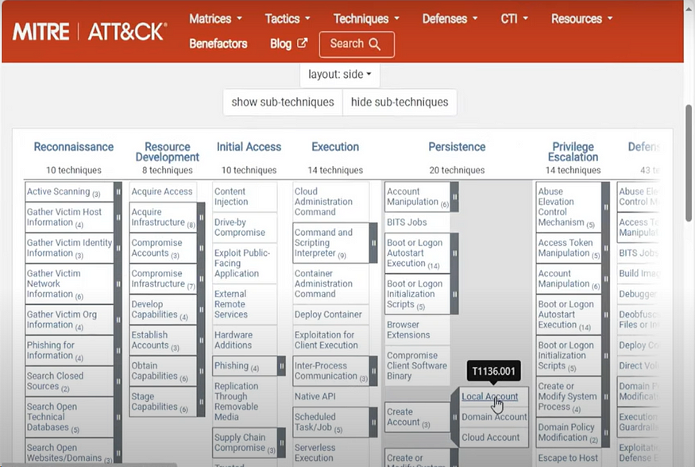

25. For this lab, I used T1136.001 for illustration. On target machine, enter the following command on PowerShell: “Invoke-AtomicTest T1136.001”. This will generate telemetry of a local account creation “NewLocalUser” which can be viewed in Splunk.

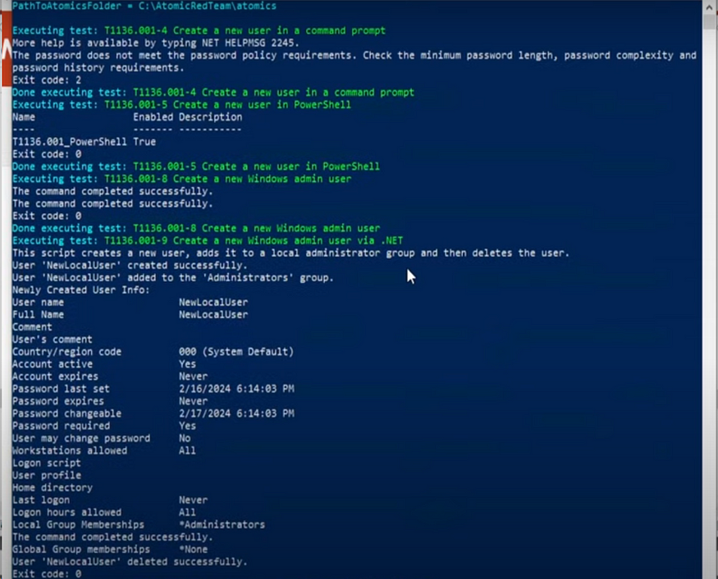

26. On Splunk Search and Reporting App, enter the search “index=endpoint NewLocalUser”. It is observed after some time that this technique is observed on Splunk. This indicates that the security measures in place can detect this technique if used by an attacker.

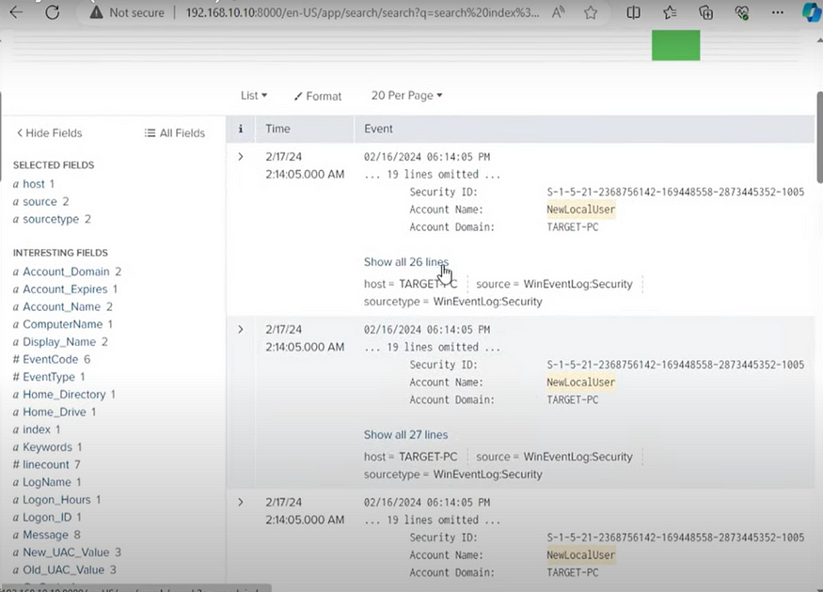

27. Try again using the Technique “T1059”.

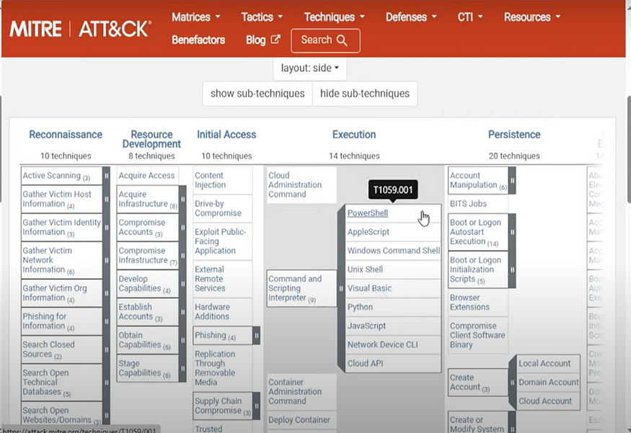

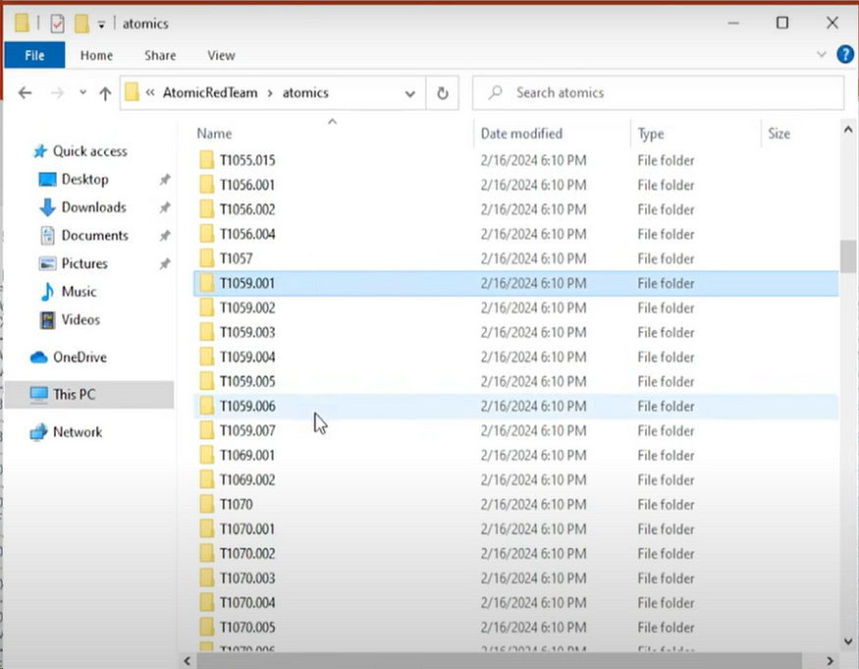

On target machine, enter the following command on PowerShell: “Invoke-AtomicTest T1059.001”. This will generate telemetry which can be viewed in Splunk.

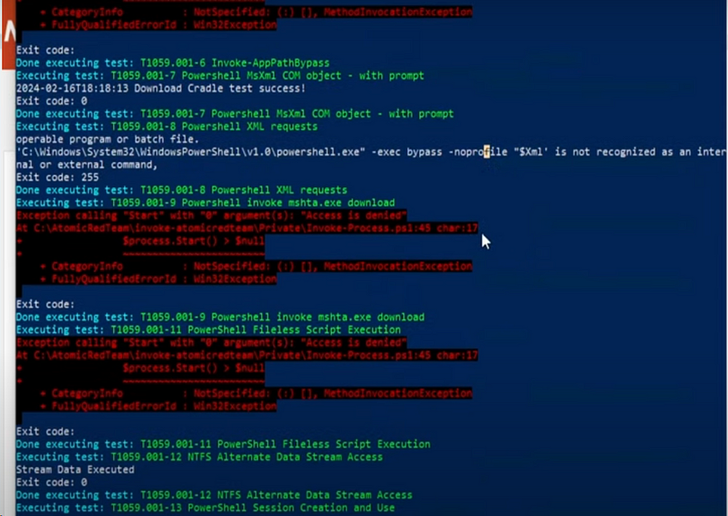

28. On Splunk Search and Reporting App, enter the search “index=endpoint PowerShell”. It is also observed that this technique is observed on Splunk which indicates that the security measures in place can detect this technique if used by an attacker.

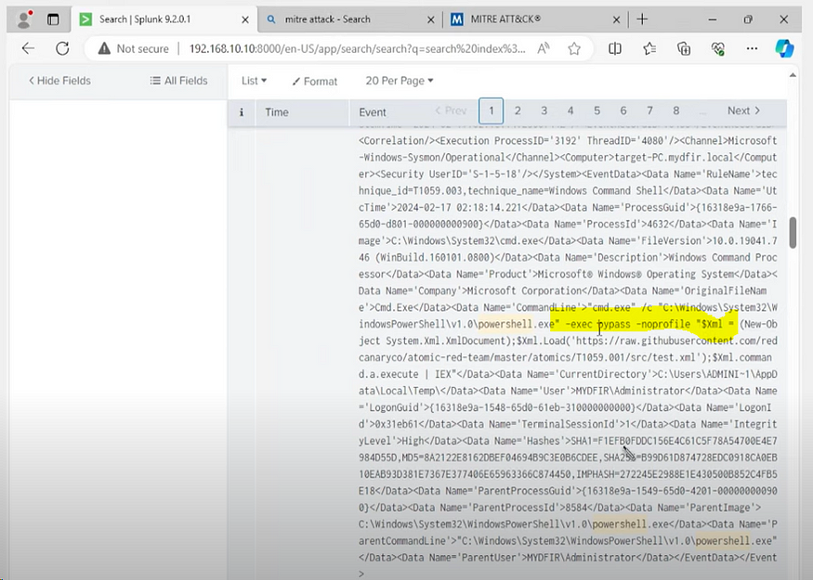

**Key Takeaways and Conclusion**

In conclusion, this lab showed the importance of having visibility provided by Splunk in detecting ongoing attacks. In addition, with this walkthrough, an IT professional can set up active directory, and create organizational units which can depict the different department in an organization, and create users.